**1. What is Spring Boot? Why should you use it?**

**Ans- Spring Boot** is an open source Java-based framework used to create a micro Service. It is developed by Pivotal Team. The main goal of the Spring Boot framework is to reduce overall development time and increase efficiency by having a default setup for unit and integration tests. Some advantages of Spring Boot are as follow:

* Dependency Management
* Auto-configuration
* Runnable jars

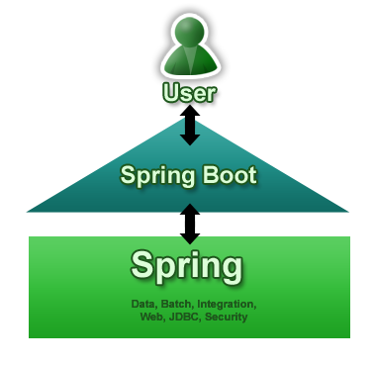

**(Fig: 1.1 Spring Boot)**

**2.What is the difference between @SpringBootApplication and @EnableAutoConfiguration annotation?**

**Ans- @EnableAutoConfiguration:-**It enables automatic configuration features of the Spring Boot application, which automatically configures things if certain classes are present in classpath   
**@SpringBootApplication:-** It does three things

* It allows you to run the Main class as a JAR with an [embedded container](https://www.java67.com/2019/07/spring-boot-3-ways-to-change-port-of-tomcat.html).
* It enables Java configuration
* It also enables Component Scanning.

**3.What is Spring Initializer? why should you use it?**

**Ans- Spring** Initializer is one of the ways to generate spring application. The main reasons for using Spring Initializer are:

* We can quickly setup and run standalone, web applications and micro services at very less time.
* We can just assemble the jar artifact which comes with an embedded Tomcat, Jetty.

**4. What is Spring Boot CLI? What are its benefits?**

**Ans- Spring Boot CLI** is a **command line** tool which is used to quickly build spring applications.

**Advantages:**

* Run Groovy scripts
* bootstrap a new project or write your own command for it

**5. Can you change the port of Embedded Tomcat server in Spring boot? If Yes, How?**

**Ans- YES,** by specifying the server.port property in the resource file.

Ex- server.port = 5050